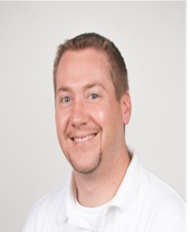**Sean Ranson**

Company & Title – Altria Group Distribution Company

District Sales Manager – Western, PA

Accomplished Sales & Marketing leader with 10 years of high level CPG experience. As a District Manager, I am responsible for designing, implementing, and strategically executing business building sales & marketing plans across thousands of retail locations within Western Pa. Additionally, I am responsible for motivating, developing and training a large, multi-structured sales organization. I have held various sales, marketing and development roles within Altria, giving me the unique opportunity to work in North Carolina, Tennessee and our headquarter building in Richmond, VA.

About Altria - Altria Group is a Fortune 200* company headquartered in Richmond, Virginia. For more than 180 years, Altria's companies have built some of the best-known brands in the world – Marlboro, Copenhagen, Skoal and Black & Mild – that today lead their respective categories. Watch this video to learn how we do business at Altria today.

Career Opportunities – [www.cantbeattheexperience.com](http://www.cantbeattheexperience.com/)